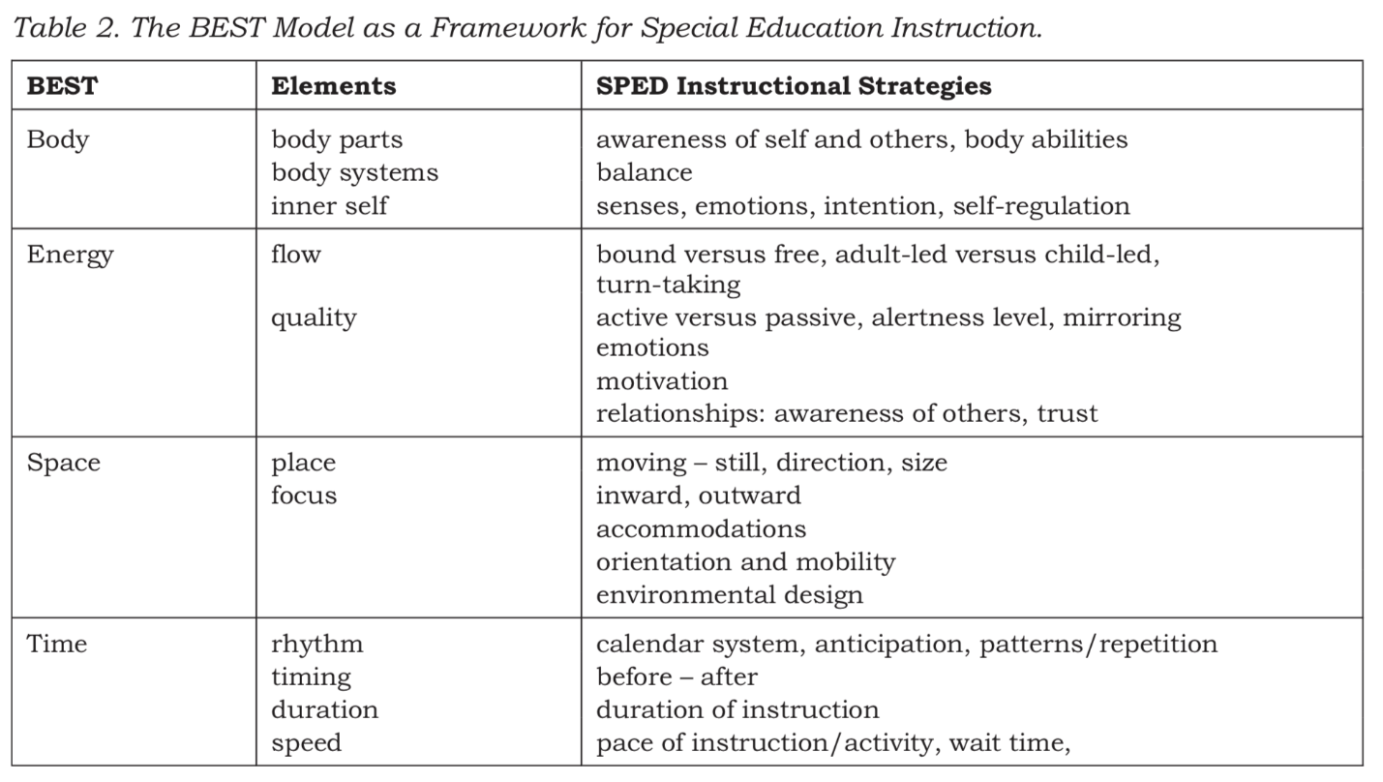
Note. Reprinted from “Creative dance-based communication intervention for children with multiple disabilities including sensory impairment.” by Nelson, Paul, & Barnhill (2017). Perspectives on Augmentative and Alternative Communication Sig 12, 2(3), 70-80. Copyright 2016 by "American Speech-Language-Hearing Association."

